
Computer Graphics
Year 9

Name: ______________________ Class: ____________
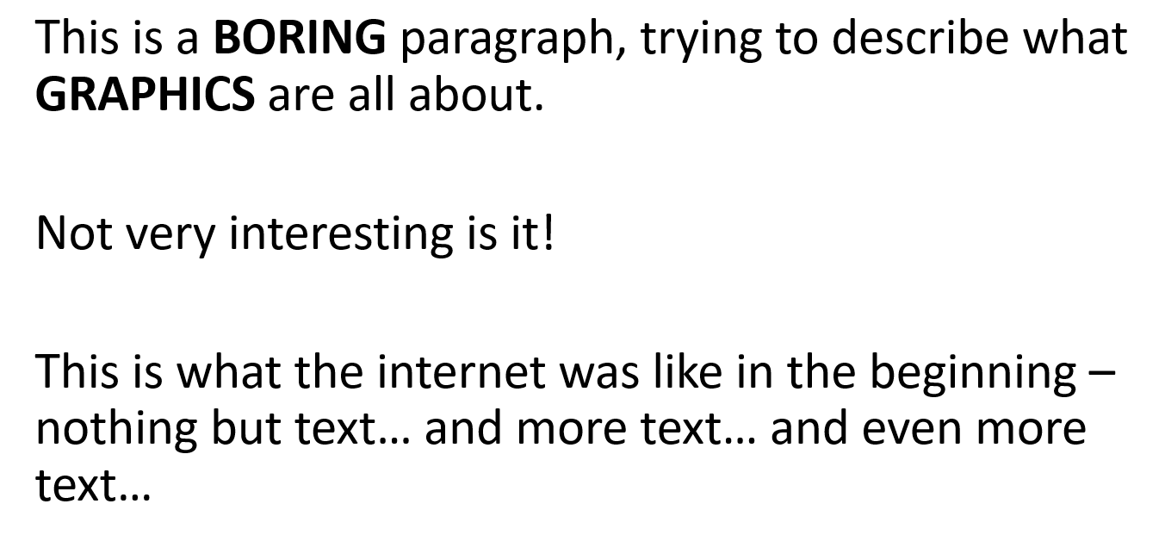

The old saying ‘a picture says a thousand words’ still holds in computer terms. Imagine a block of text in a TV advertisement, or a paragraph as an invitation to a party. In recent years, people’s attention span has been drastically reduced. Does your attention hold when you are watching a TV program, or do you have your phone in your hand scrolling through Facebook or Instagram every few minutes?
Whole apps are now developed solely interest you by showing you images. Think of Snapchat, or Instagram – even Tik Tok. These Apps have been made as trends show your attention span lasts under 30seconds on any one image or short video clip.

Computer Images and promotions have to be short, snappy and informative.

How Graphics are Used
Graphics are seen everywhere around us. Images are used to convey all kinds of information and messages. They are used in:
- Logos
- Road Signs
- Book Covers
- Magazines
- CD Covers
- Concept Art
- Product Packaging – along with many others
They are used to:
- Entertain
- Promote
- Inform
- Advertise
- Educate

Activity 1
Mr Butler is looking for a new logo for his Computer Graphics Company. He is looking to include:
- 3-5 colours used
- A simple image or text
- Clear, easily printed logo.

Use the space below to design a logo which is eye catching, clear and tells potential customers what the company can offer!

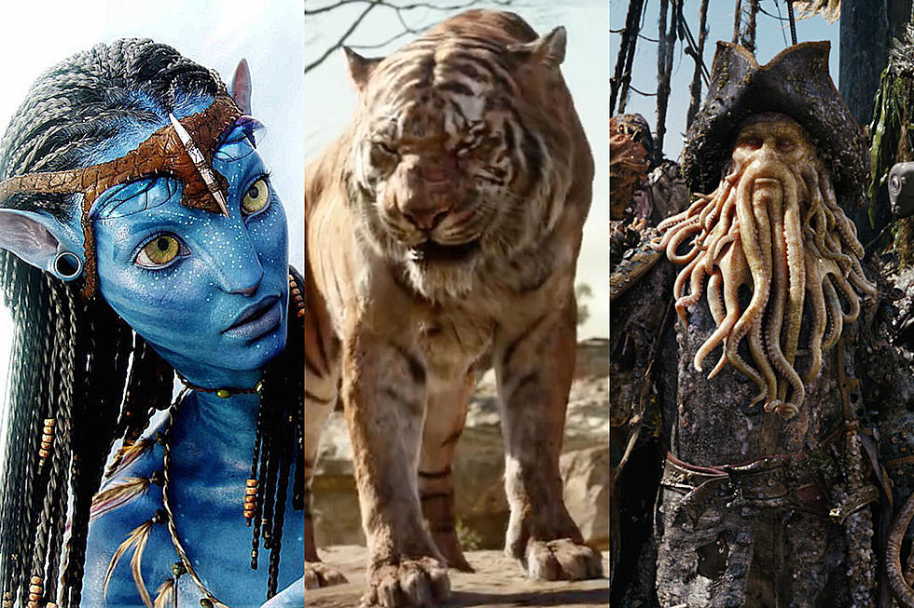
CGI
Figure 1 - CGI is used in films and TV

At the most basic level, Computer-Generated Imagery is the creation of still or animated visual content with computer software.
CGI most commonly refers to the 3D computer graphics used to create characters, scenes and special effects in films, television and games.

Sources of Computer Graphics
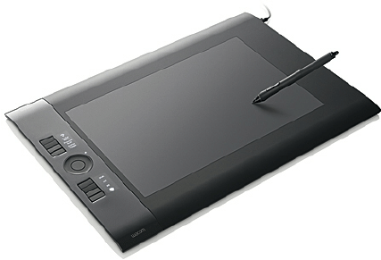
Digital Graphics are used in a variety of multimedia products, and in fact it is extremely rare to see a multimedia product without some form of graphical asset.
Figure 2 - A Graphics Digitiser
There are lots of different sources of computer graphics, including:
- Search Engines to find premade graphics
- A Digital Camera
- Clipart
- Hand Drawn Images Using a Graphics Digitiser
A scanner is not a source of graphics – it is a source for importing graphics into a computer

Key Terms Used in Computer Graphics
We use a lot of key terms when discussing computer graphics – these include:
- DPI
Stands for Dots Per Inch. Usually refers to printer quality. The higher the dpi, the better the quality of the image.
- Pixelated
A ‘low resolution’ image will look ‘pixelated’ when it is scaled up for printing. A ‘high resolution’ image will still be clear when scaled up.
- Pixel Dimension
These are the horizontal and vertical measurements of an image and is expressed in pixels. The pixel dimensions may be determined by multiplying both the width and the height by the dpi.
- Lossy and Lossless Compression
Lossless compression means you can make the file size smaller to store, and when restored, it will still retain its quality. In lossy compression, the quality is lost when the storage size is reduced (compressed). You will not be able to get the quality back as it is permanently lost (but the file size is smaller).

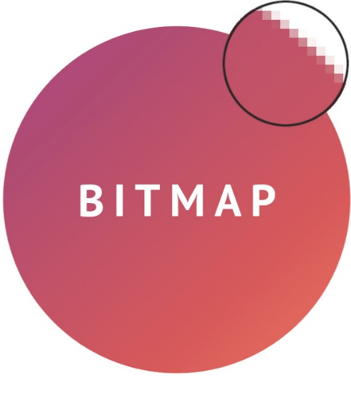
Bitmap and Vector Graphics
Figure 3 - Bitmap Images use a grid of pixels
Bitmap images are made up of a grid of tiny square dots called pixels. Each pixel can be its own colour – but only one colour at any one time!
When you zoom into a bitmap image, it is possible to see these individual pixels, or you see these ‘jagged’ edges. This is called pixilation. Bitmaps store information on each individual pixel, meaning it is perfect for highly detailed photographs – however, can result in large file sizes.

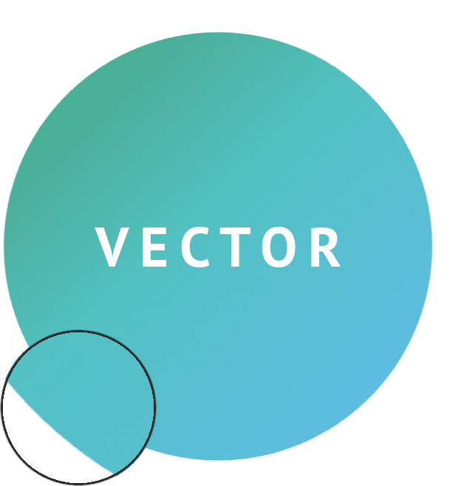
Figure 4 - Vector Graphics use Mathematical equations

Some graphics do not use a grid of pixels, but instead are ‘calculated’ using mathematical equations to create lines, curves and shapes.
It’s easily scalable/resizable as it doesn’t rely on fixed point references or grids to create its shapes.
Although, think of how many individual shapes would be required for a photo – too many individual shapes so Vector graphics should only be used for simple images such as logos.

Graphics Packages
There are a LOT of different ways to create and manipulate (edit) computer graphics. One of the most famous of these is Adobe Photoshop, but there are a LOT. This is because different packages offer specialised tools for editing different file types, and also others offer various levels of complexity for different levels of user ability.
A novice user could use a package such as Microsoft Paint, whilst a professional user would much prefer Adobe Illustrator as it offers a much more detailed way to edit and create graphics.
Some examples include:
- Microsoft Paint
- PIXLR
- Adobe Photoshop
- Picasa
- Paintshop Pro

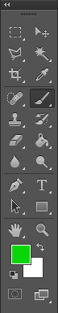

Using Some of the Tools in Adobe Photoshop
This task will involve several tools available in Adobe Photoshop listed on the previous page. Once complete, label where the different tools you used to manipulate the digital graphic are on the graphic.

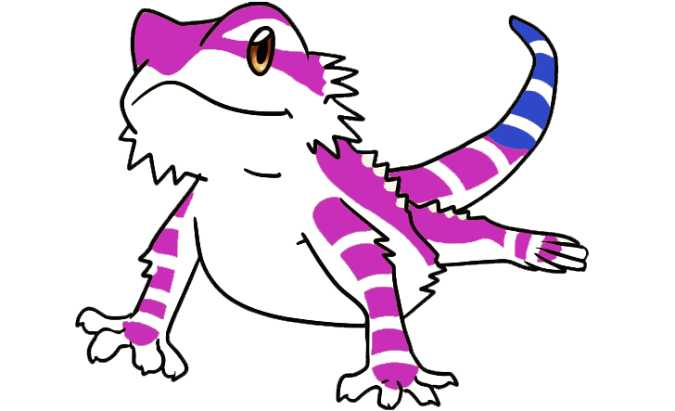

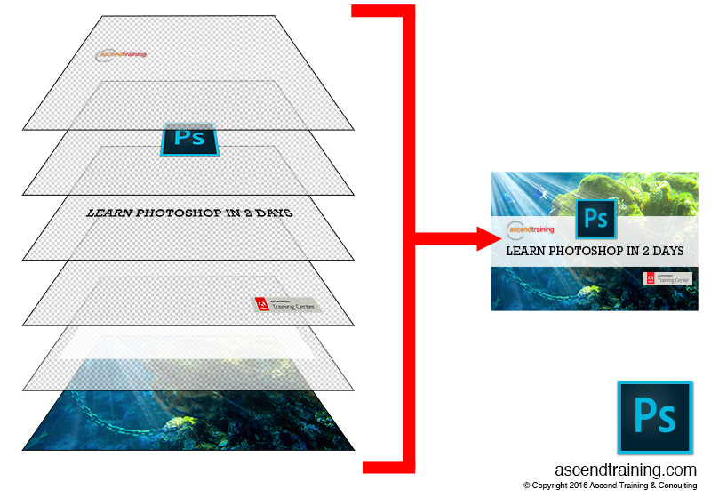
Image Layers
Photoshop Layers allows us to have multiple images existing together on separate layers. This enables you to keep all your elements independent of each other.
These layers are non-intersecting planes in where images and elements are separate. Each image that was scanned or shot by a digital camera comes with a Background layer.
This layer is like the glue on the back of a stamp in that you cannot move it above any other layer, and it cannot contain transparent pixels.

